Cave Café Documentation (Rush Hour)

# Objectives

1. Determine the rush (month – week – day-hour) with two slots ex: (Day – Night)

## Preparing the data :

1. I viewed the data to know what colomns I should deal with but first I changed the (Name) and (category) colomn from Arabic to English using this code :

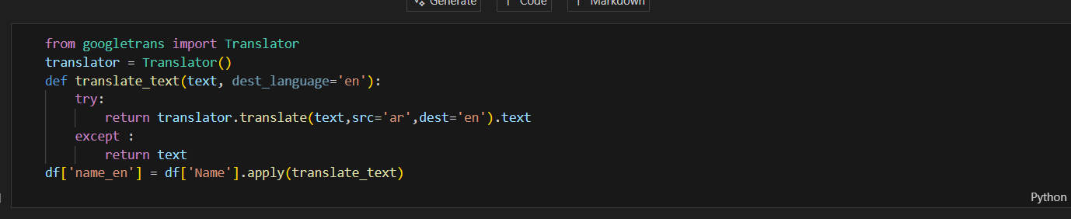

I did this so if I wanted to plot most sold products and categories in a month or day

1. I separated the ‘StartSession’ colomn to month , week , days , hour:

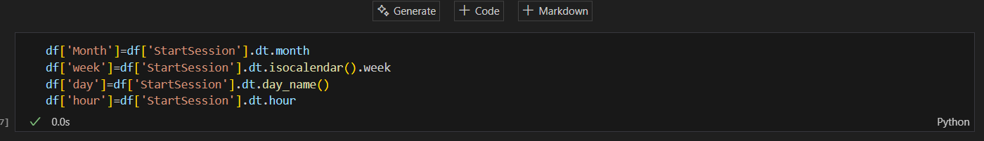

1. Then I separated the day into two shifts (day-night) knowing that the café is 24 7 I made a 12 hour day shift from 6 to 18 and 12 hour night shift from 18 to 6 :

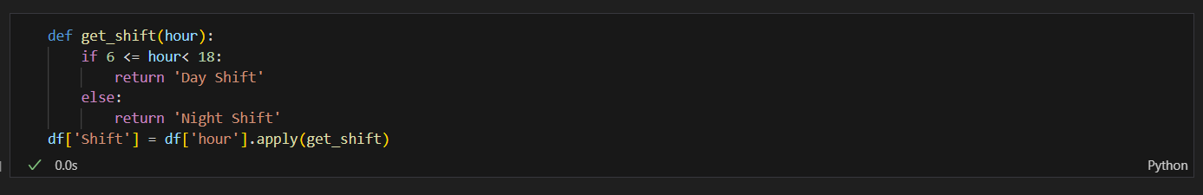

## Plotting the data :

1. 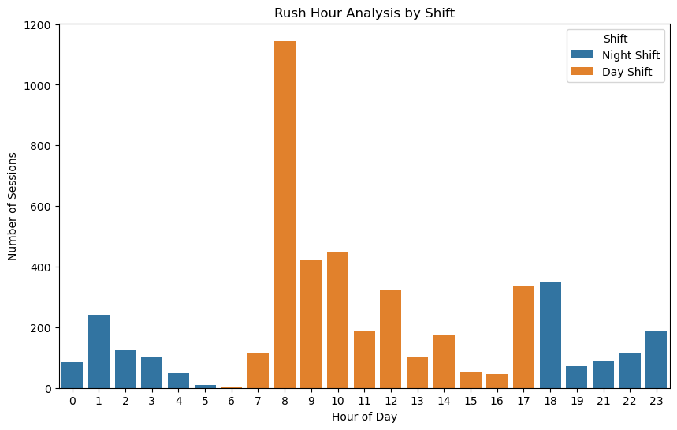I plotted the rush hour using **Seaborn** library finding the most rush hour which is 8 am in the day shift :
2. Then I tried to find the most busy days and if i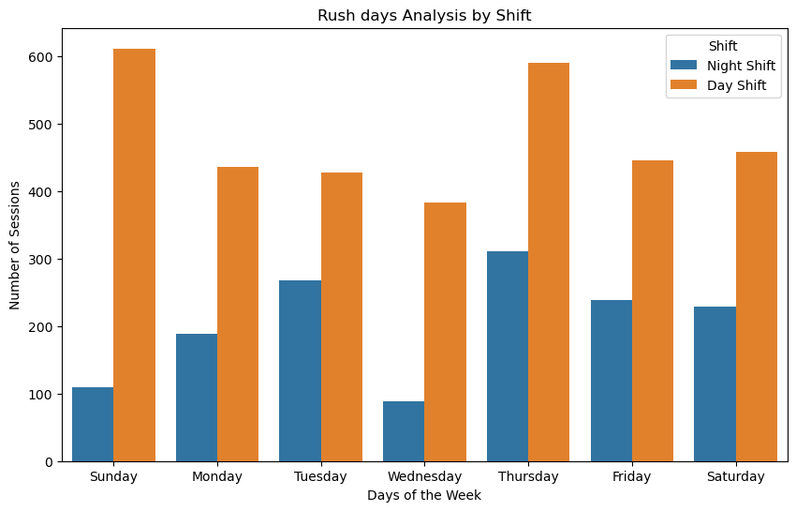t the **night** or **day** shift :
3. Then to find the most **busy month** I used a time series :

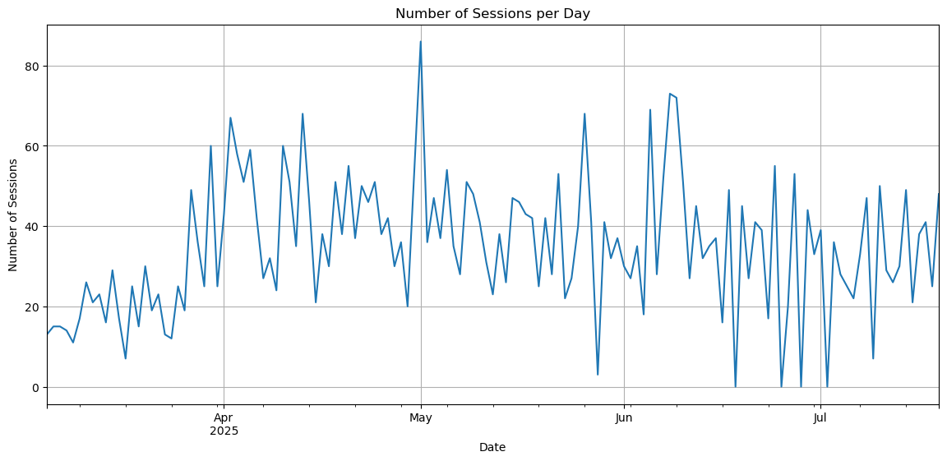

1. And to find the most busy month with most busy hour in details I grouped by the **month** with **hour** :

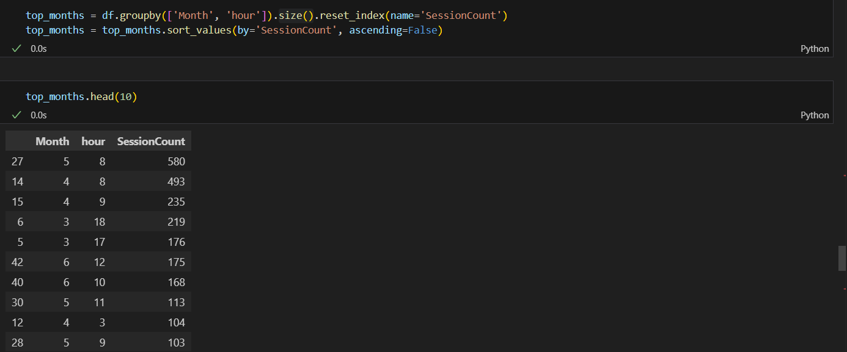

1. To plot it I made a **heat map** :

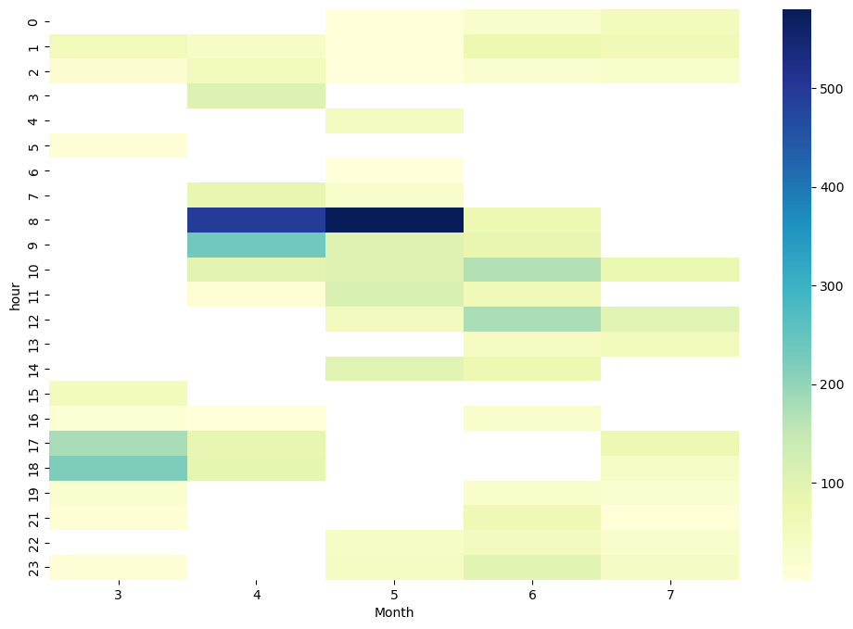

### Key Insights:

**1. Rush Hour Behavior**

* **Peak traffic time:** 8:00 AM — The café attracts a strong morning crowd, likely composed of commuters, students, and office workers.
* **Business implication:** Strengthen breakfast and coffee offerings, introduce “morning combos,” and ensure staffing levels are optimized before 8 AM.

**2. Shift Performance**

* **Day shift consistently outperforms night shift** — Customer activity is concentrated during daytime hours.
* **Business implication:** Focus marketing and new product launches on day shift hours, while introducing promotions or entertainment during evenings to boost night sales.

**3. Weekly Demand Patterns**

* **Busiest days:** Sunday (highest) followed by Thursday.
* **Possible reasons:** Sunday leisure outings; Thursday as a pre-weekend social day.
* **Business implication:** Capitalize on high-traffic days with premium offers, or special menu items. Consider midweek promotions to balance demand.

**4. Monthly Trends**

* **Busiest month:** May — Likely influenced by seasonal factors such as weather, public holidays, or local events.
* **Business implication:** Plan targeted campaigns and product launches in May. Analyze May’s past promotions/events to replicate success.

**5. Strategic Recommendations**

1. **Breakfast Focus:** Expand breakfast menu and create loyalty programs for morning customers.
2. **Evening Engagement:** Offer discounts, themed nights, or entertainment to attract night-time visitors.
3. **High-Demand Days:** Create Thursday & Sunday signature specials to maximize revenue.
4. **Seasonal Optimization:** Prepare special events and marketing pushes for peak months, and design strategies to lift off-peak performance.